1️⃣6️⃣ HTML HEAD ELEMENTS
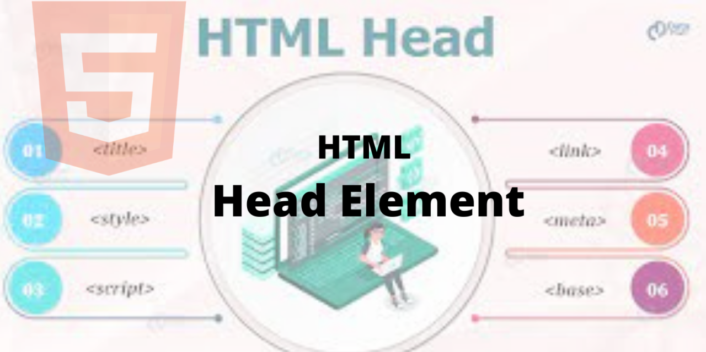
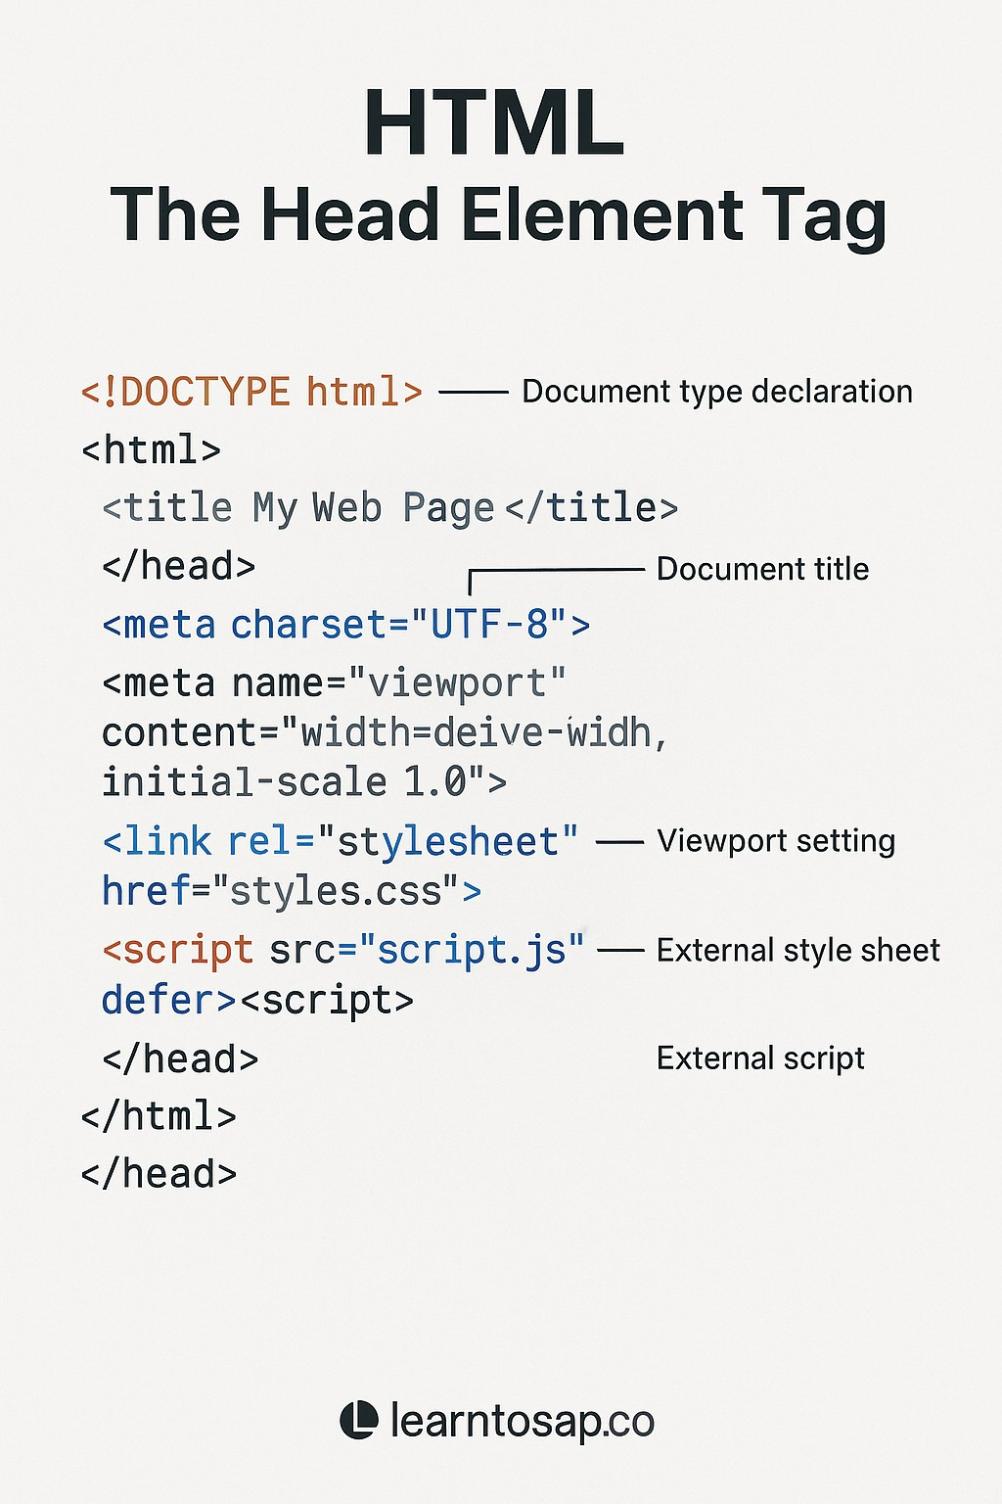
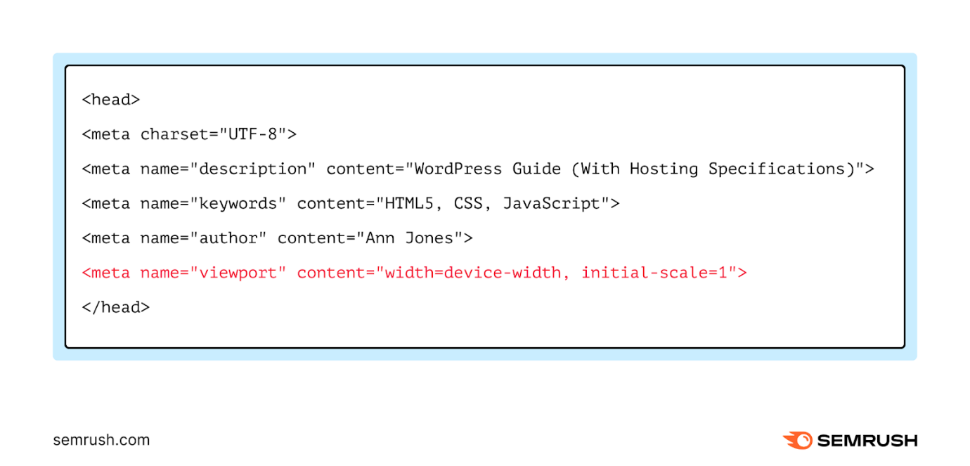
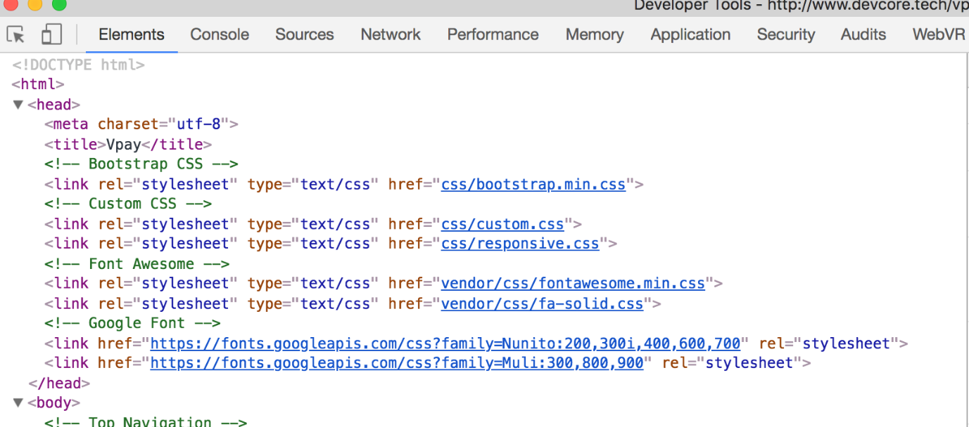
The <head> section contains metadata (data about the webpage).
It is NOT visible to users but CRITICAL for browsers, SEO, and performance.

🔹 <title>
Sets the browser tab name and affects SEO.
<title>My Website</title>
📌 Appears in:
✔ Browser tab
✔ Search engine results

🔹 <meta>
Provides information about the page.
<meta charset="UTF-8">
<meta name="viewport" content="width=device-width, initial-scale=1.0">
✔ Charset
✔ SEO
✔ Responsive behavior

🔹 <link>
Used to link external resources (mostly CSS).
<link rel="stylesheet" href="style.css">

🔹 <style>
Used for internal CSS.
<style>
p { color: red; }
</style>

🔹 <script>
Used to add JavaScript.
<script src="app.js"></script>
📌 Best practice: load JS at bottom or with defer.

🔹 <base>
Sets a base URL for all relative links.
<base href="https://example.com/">
📌 Rarely used but asked in interviews.

1️⃣7️⃣ HTML SEMANTIC ELEMENTS 🔥🔥
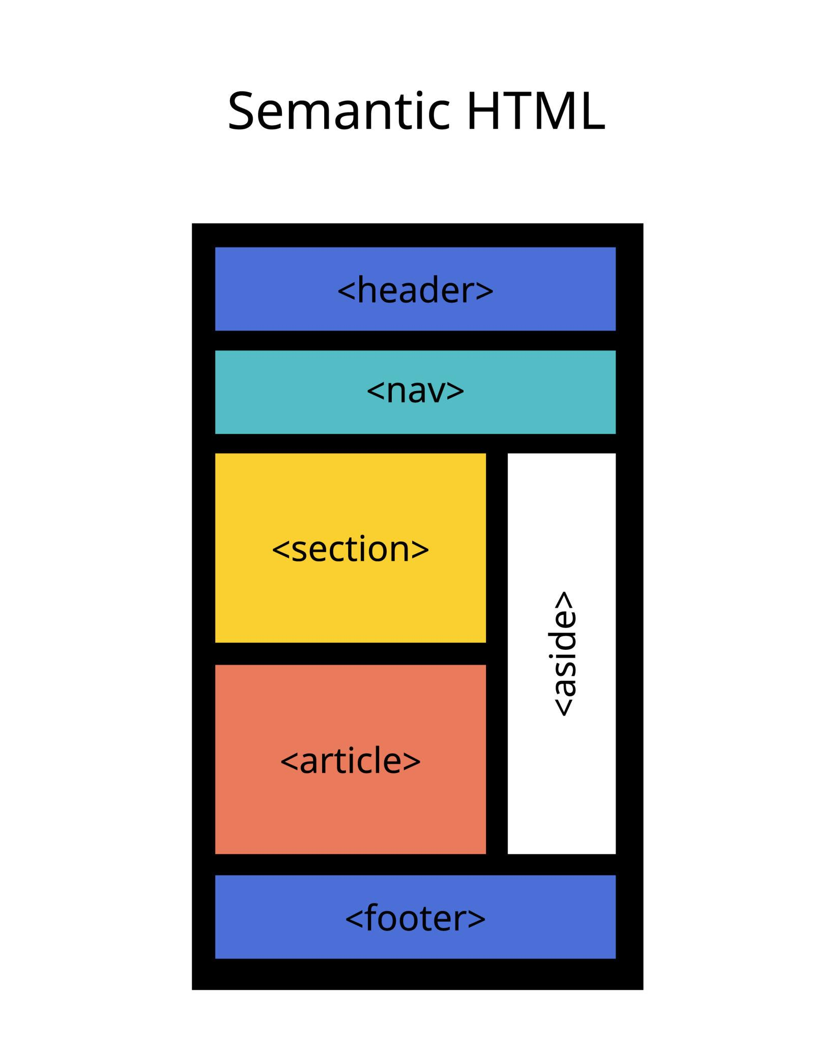
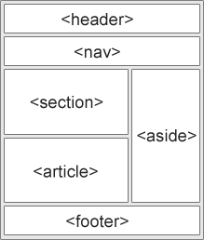
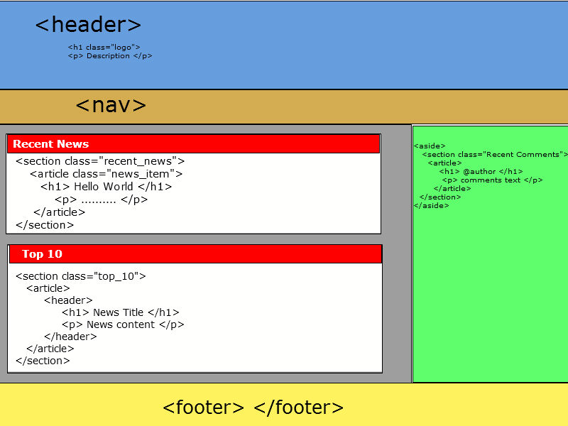

Semantic elements give meaning to content — not just structure.

🔹 Common Semantic Elements
Tag | Purpose
<header> | Page/header section
<nav> | Navigation
<main> | Main content
<section> | Logical grouping
<article> | Independent content
<aside> | Side content
<footer> | Footer info
<figure> | Image/diagram
<figcaption> | Caption

<article>
<h2>Blog Title</h2>
<p>Blog content</p>
</article>

📌 Why Semantic HTML is IMPORTANT?
✔ SEO
✔ Accessibility (screen readers)
✔ Clean & maintainable code
📌 Interview Line 🔥:
Semantic tags help machines understand your content.

1️⃣8️⃣ HTML LAYOUT
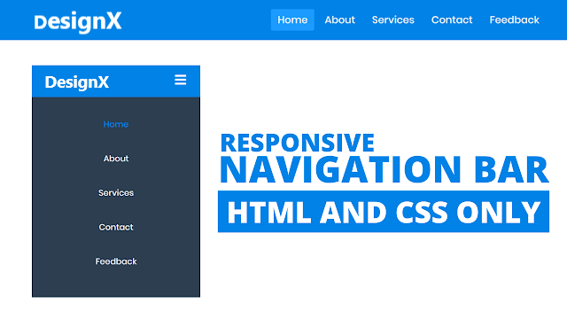
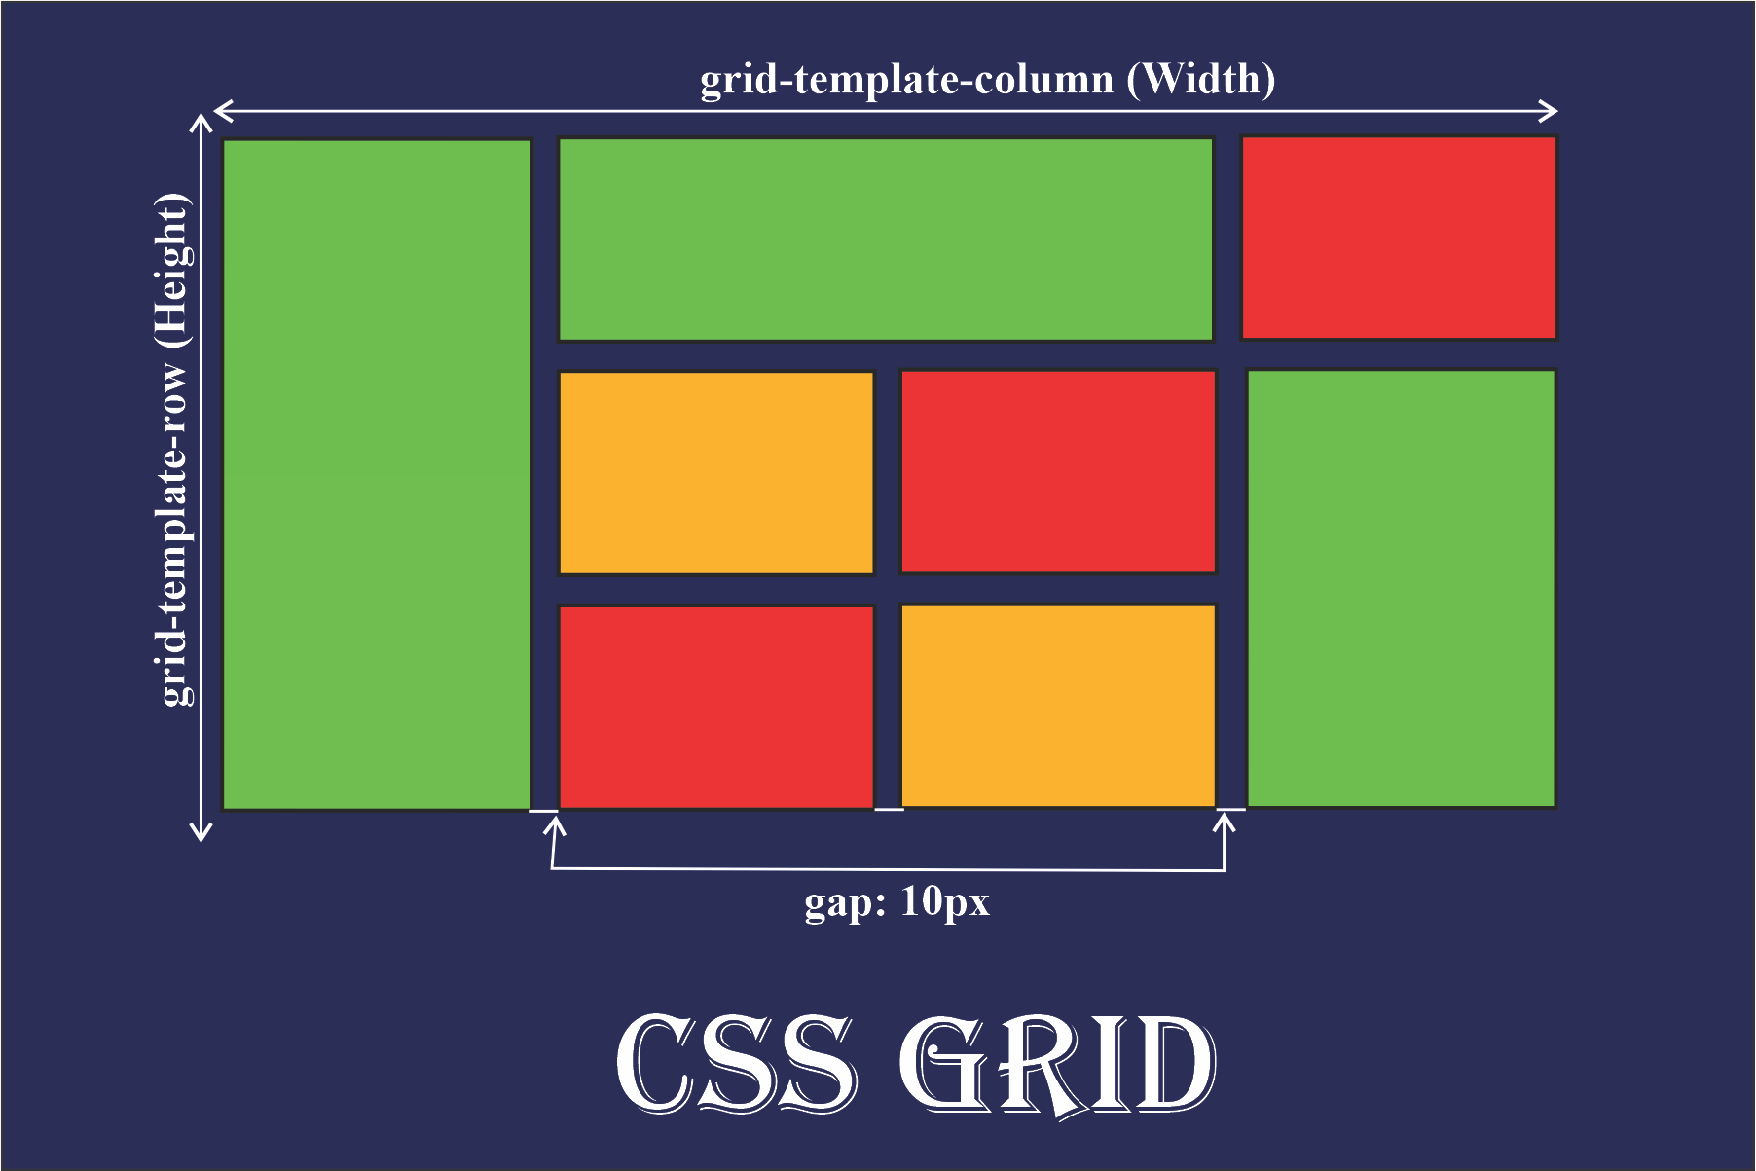
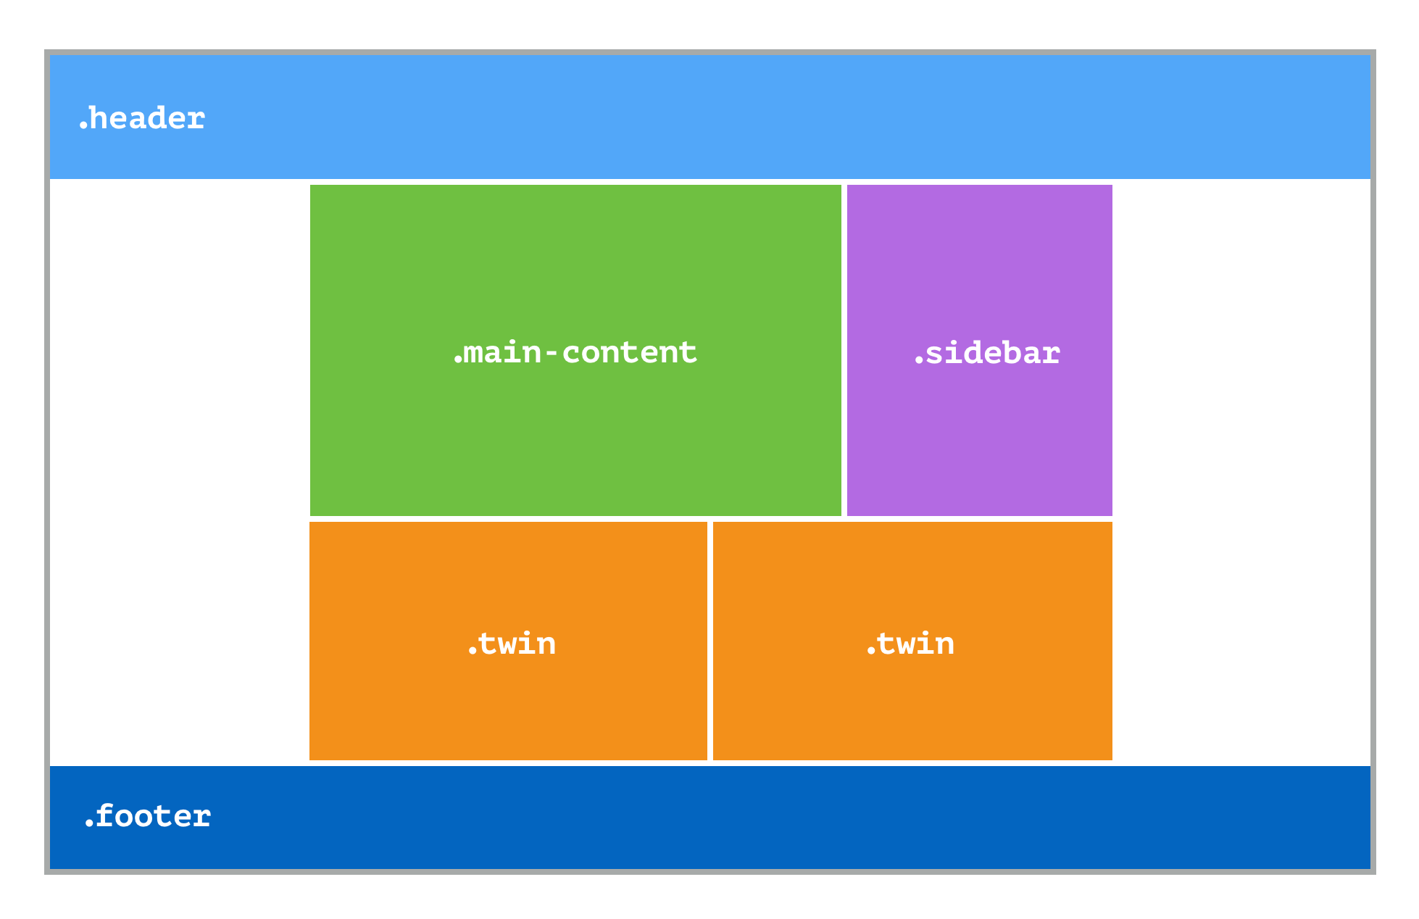
HTML layout defines how content is arranged on the page.

🔹 Common Layout Patterns
1️⃣ Header – Content – Footer
<header>Header</header>
<main>Content</main>
<footer>Footer</footer>

2️⃣ Navbar Layout
<nav>Menu</nav>
<section>Main Content</section>

3️⃣ Grid-Based Structure
Modern layouts use CSS Grid & Flexbox.
📌 HTML creates structure, CSS handles layout.

1️⃣9️⃣ HTML RESPONSIVE DESIGN 📱
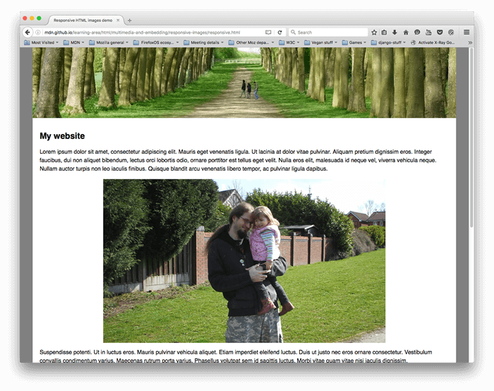
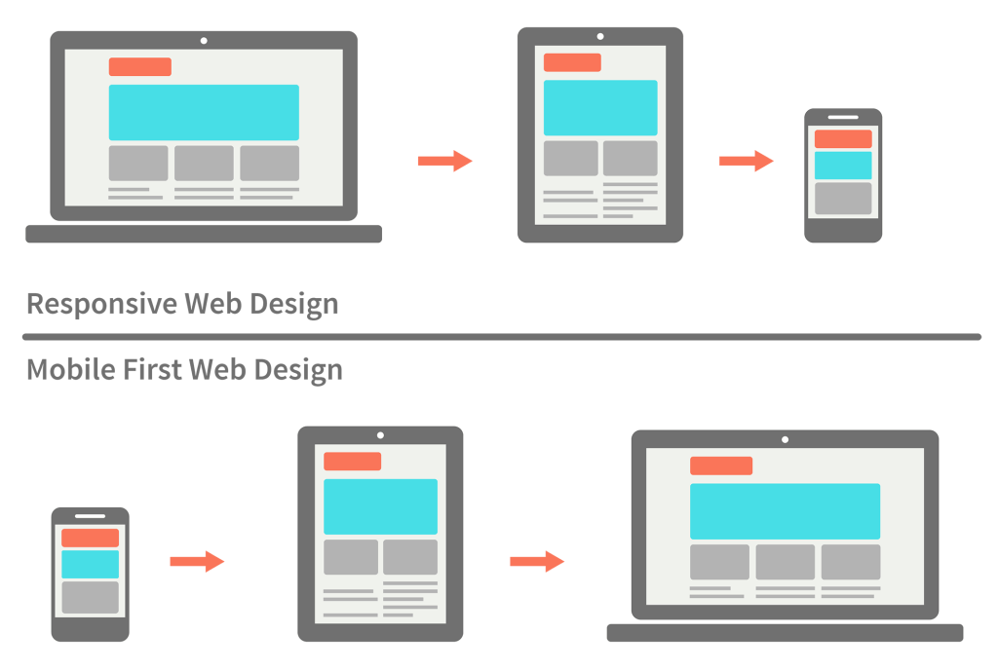
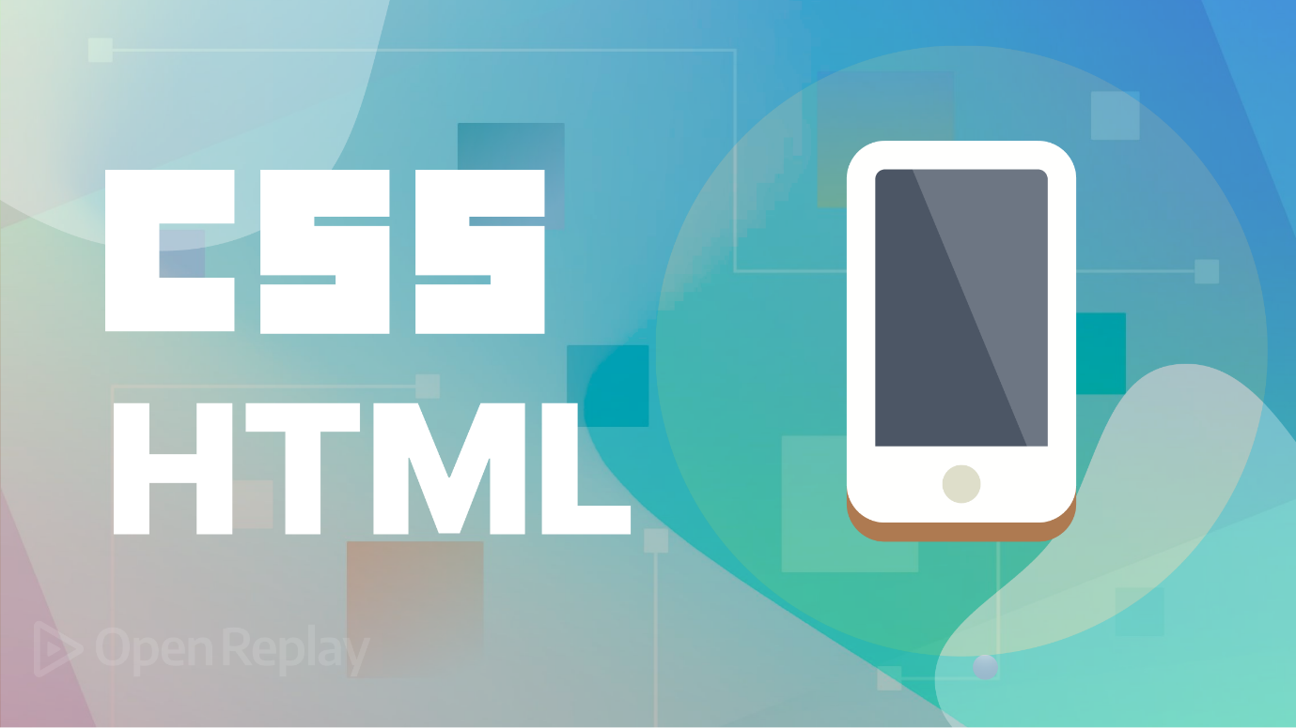
Responsive design ensures your website works on all devices.

🔹 Viewport Meta Tag (MANDATORY 🔥)
<meta name="viewport" content="width=device-width, initial-scale=1.0">
❌ Without this → Mobile breaks
✔ With this → Responsive layout works

🔹 Responsive Images
<img src="img.jpg" style="max-width:100%;">

🔹 Mobile-First HTML
Design for mobile first, then desktop.
📌 Industry standard approach.

2️⃣0️⃣ HTML CSS INTEGRATION
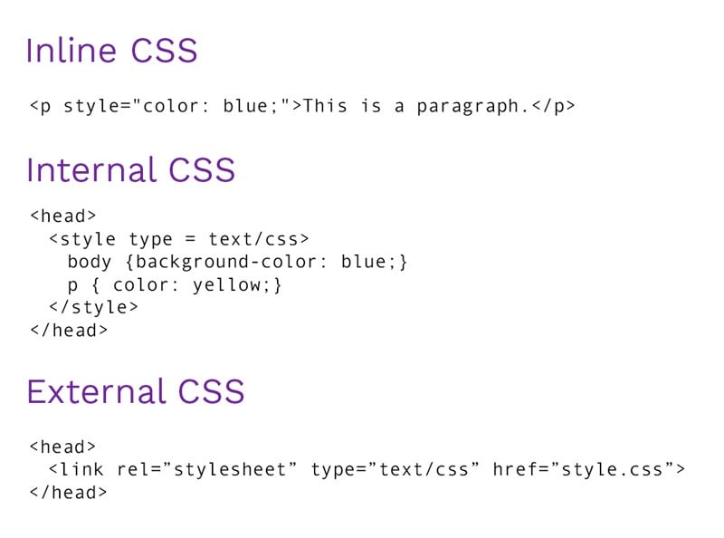
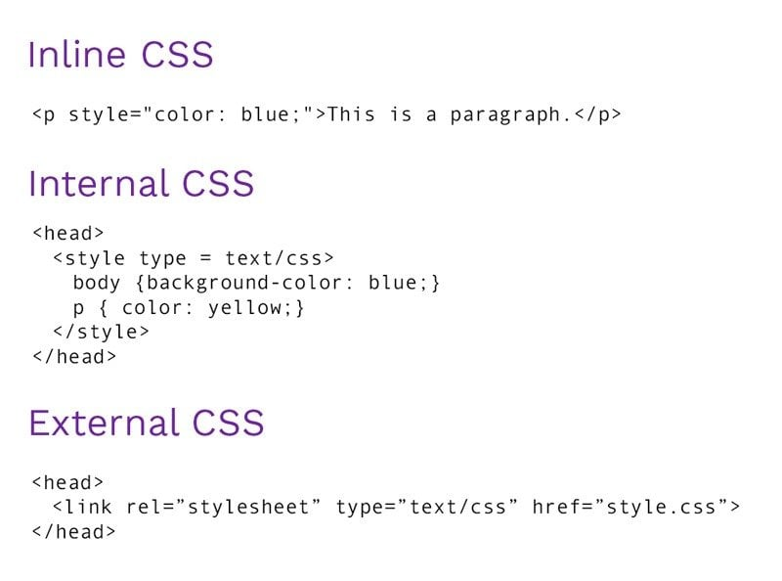
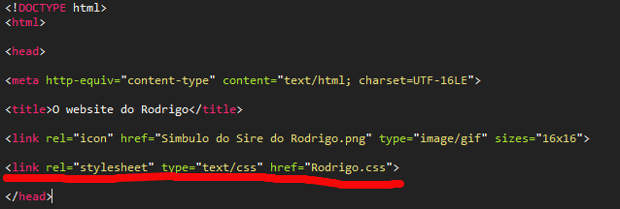
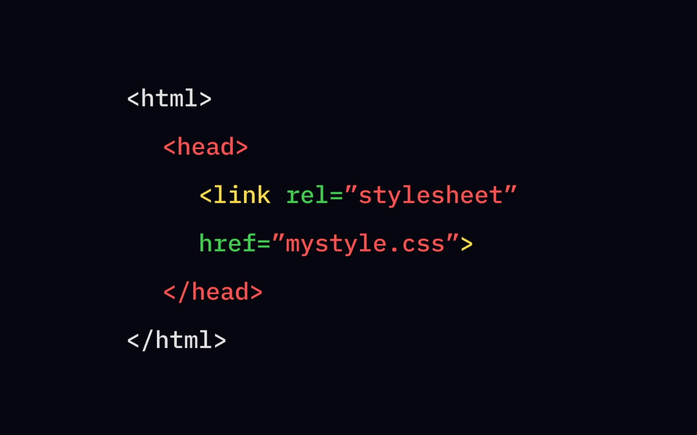
HTML integrates CSS in three ways.

🔹 Inline CSS
<p style="color:red;">Text</p>
✔ Quick testing
❌ Bad practice for projects

🔹 Internal CSS
<style>
p { color: blue; }
</style>
✔ Small pages
❌ Not scalable

🔹 External CSS (BEST PRACTICE ✅)
<link rel="stylesheet" href="style.css">
✔ Reusable
✔ Clean code
✔ Fast loading
📌 Interview Tip:
Always prefer external CSS.

🧠 TEACHING GOLD POINTS 🔥
✔ <head> = invisible but powerful
✔ Semantic HTML = SEO + accessibility
✔ Layout = structure first, style later
✔ Responsive = mobile-first
✔ External CSS = industry standard

NEXT (You choose 🚀)
✔ HTML SEO (advanced)
✔ Accessibility (A11Y deep dive)
✔ Interview Q&A + MCQs
✔ PDF / PPT version
✔ Practice assignments
Just tell me 👍

